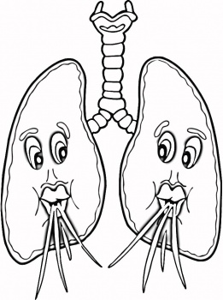
ANIMALS: STRUCTURE AND FUNCTION

Respiratory System

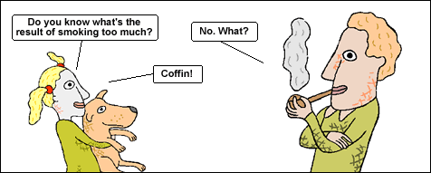

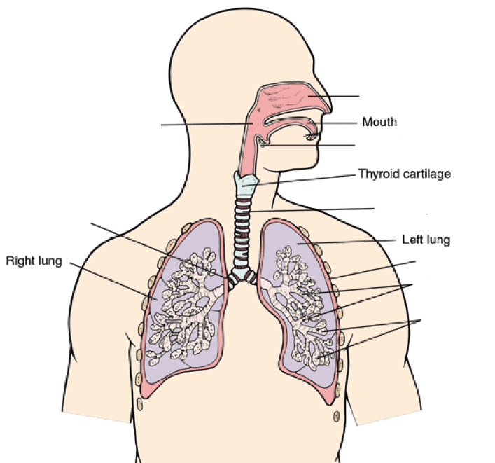

Human Respiratory System- Parts and Function
Part | Description
Nasal Passages
Pharynx
Trachea
Glottis/Epiglottis

Larynx

Bronchi (singular Bronchus)

Bronchioles

Alveoli (singular Alveolus)

Pleura

Four Stages of Respiration
- Breathing
a) Inspiration-

b) Expiration-

- External Respiration (gas exchange)
- Internal Respiration

- Cellular Respiration

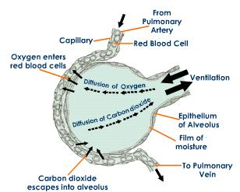

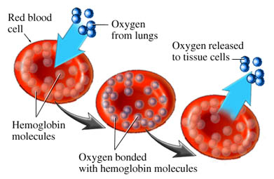

2 main requirements for respiration
Respiratory Surface:
a)

b)

Types of Respiratory Surfaces in Animals
Description of Respiratory Surface | Example
Outer Skin | 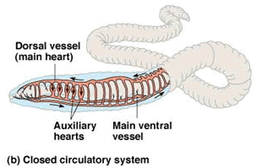  Earthworm
Gills | 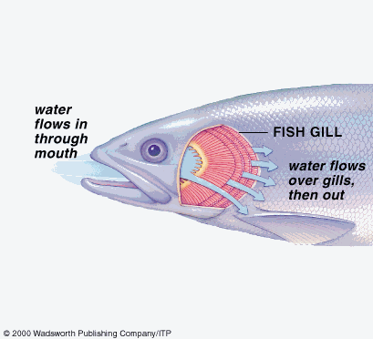  Fish
Tracheal System | 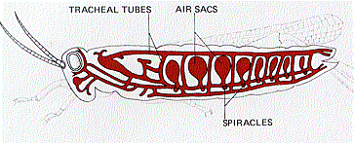  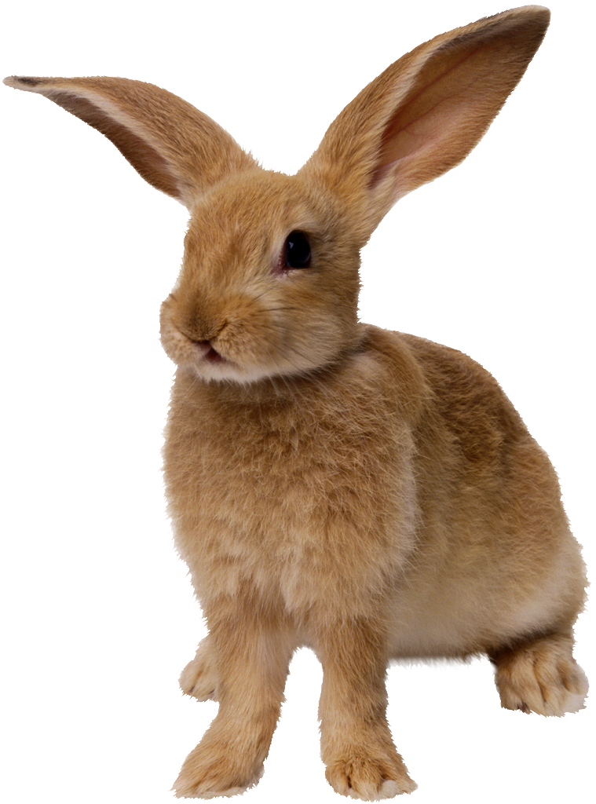  Insect
Lungs | Rabbit

Mechanisms of Breathing
2 sets of structures control the air pressure inside the lungs:
1. Diaphragm

2. Rib Muscles (aka intercostal muscles)

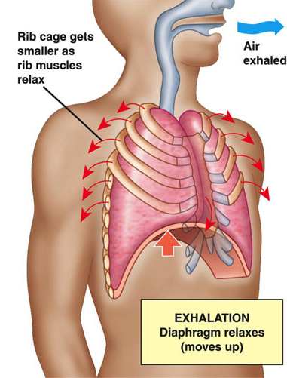
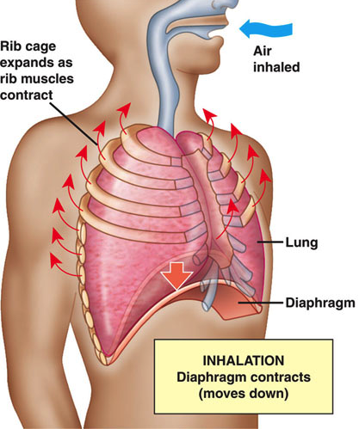

Respiratory Volume
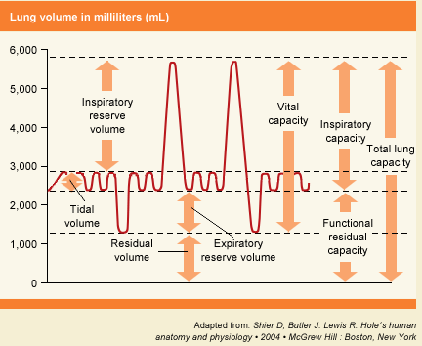

Tidal volume-

Inspiratory Reserve volume-

Expiratory Reserve volume-

Vital Capacity-

Residual volume-
Respiratory System Disorders
Disorders of the Upper Respiratory System
Tonsillitis
Laryngitis
Disorders of the Lower Respiratory System
Pneumonia
Bronchitis
Asthma
Emphysema
Cystic Fibrosis
Lung Cancer

